Welbury - a local history

edited by
A Ovenston and M J O’Carroll

a millennium project supported by Welbury Parish Council, Yorkshire Water and a Help the Aged Millennium Award funded by the National Lottery

project team: Stuart Mackie, Mike O’Carroll, Angela Ovenston, Geoff Sharp, Betty Unwin and Gordon Wade

picture editor: John Ovenston

Garden House Publishing

British Library Cataloguing-in-Publication Data

Welbury : a local history
1.Welbury (England) - History
I.Ovenston, A II.O'Carroll, M. J.
942.8'4

ISBN 0950699470

© Garden House Publishing 2000

All rights reserved. No part of this book may be reproduced in any form without the prior written consent of the publisher.

Garden House Publishing
(incorporating Emjoc Press, established 1979)
Garden House, Welbury, Northallerton DL6 2SE, UK

ISBN 0950 6994 7 0

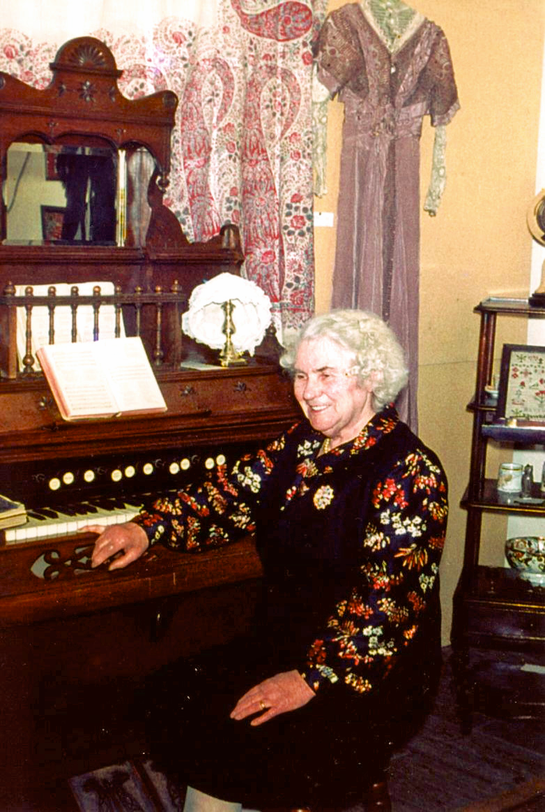
Mrs M E Boyes, the inspiration for this book,
presiding over a Victoriana Exhibition in the mid 1970s
in the old Welbury Village Hall.

Introduction and acknowledgements
Like many other projects, this book was prompted by the turn of the millennium. The Welbury Parish Council had asked for ideas to commemorate such a rare and significant event, and so the Welbury History Project was under way in 1999.
If the millennium was the prompt, the inspiration was undoubtedly Mrs Mary Ellen Boyes. She came to Welbury as a two year old, at the beginning of the twentieth century. A perceptive observer, with a clear memory reaching back into early childhood, she took a keen interest in local history somewhat ahead of her time; discussions with villagers have often referred to what Mrs Boyes had said. Fortunately she recorded her observations and historical notes in exercise books during the 1960s and 70s.
It is fitting therefore to show Mrs Boyes presiding over the Victoriana exhibition in our frontispiece. Her notes relating to life in Welbury are reproduced in the book. Her son Frank Boyes, and other members of the family, have made the notes available and supported the project with their own extensive recollections.
The book in its substantial form would not have been possible without sponsors. Firstly, we are pleased to record our thanks and acknowledgement to Welbury Parish Council for a £50 donation to help start the project. Secondly, Andy Hinton, Director of Customer Services, kindly arranged a donation of £500 from Yorkshire Water. Then application for a Help the Aged Millennium Award, funded by the National Lottery, was successful and a grant of almost £5,000 was gratefully received. This provided for free copies to be distributed to residents of Welbury.
Encouraged by the grants, and now pressed by the restricted time scale, both for spending the Millennium Grant and for delivering the book, the team set about its work. The objective was to provide a durable and valued commemorative book for the village. Yet it could not be exhaustive. We would collect what we reasonably could in the time available.
Sources are given, sometimes with comments about them, to assist people in following up details. There is very much more to do, particularly searching and distilling primary records of courts, local authorities, estates and historical organisations. We have tried to build a picture of Welbury through the ages, to give a source for most of the better known "facts", and to indicate where major contemporaneous historical developments might have impacted upon the village.
We are grateful for the help, and in some instances permission to extract from sources, of the North Yorkshire County Reference Library at Northallerton, the County Records Office, the County Heritage Unit, Thirsk Museum, the Dorman Museum, Middlesbrough Reference Library, the University of Teesside Library, the West Yorkshire Archive Service in Leeds who keep the Harewood Estate records, Jane Greenwell who made available her collection of photographs of village life, and the many residents who made material available.
Alongside the documentary work, and this was much the greater motivation, we sought to capture reminiscences of Welbury life especially from the older generation. We relied on volunteers coming forward. We were certainly not disappointed! The many stories emerging were both fascinating and amusing. The older residents have seen the transformation from horse-powered agriculture, through the first motor cars in the village, to today's racy world of commuters and computers. And it's not all for the better! People knew, and helped, each other better in a more stable community.
Some contributors have written their own pieces for the book. Others have given interviews to recount their reminiscences. Some have provided interesting documents, such as old stories, letters, deeds, poems and notices. Many have provided photographs, several going back to the middle of the 19th Century (some are to be stored in the archive) and many have helped check the text at various stages throughout the project. Some have contributed special articles. So many have helped in large or small measure that it is difficult to provide either a complete list or to single out individuals here, but sources are acknowledged in the relevant chapters.
We hope this book will be not only commemorative, but also a stimulation for further interest in local history in the future. An archive has been created to keep some of the detailed material from which the book is drawn. It will be possible to accumulate new material for the archive, perhaps from future events, as well as from new discoveries of old times.
There remain two great mysteries. When was there a first settlement in Welbury? There is good evidence that the nearby area has been populated since the iron age and probably since the stone age, but records of definite settlement strictly in Welbury go back only a thousand years. Secondly, what is the origin of the substantial platform behind School House? Was it the original manor of the Domesday book, or was it something entirely different?
The Welbury History Project team initially was Mike O'Carroll, Angela Ovenston, Geoff Sharp, Betty Unwin and Gordon Wade. It was later joined by Stuart Mackie. John Ovenston provided technical support. Linda Adamska, Yvonne Clinton and Linda Crosby have assisted with typing. Despite leaving the village near the end of 1999, John Ovenston has scanned and processed all the images and Angela Ovenston has retained editorial co-ordination of the text.

Mike O'Carroll
April 2000

List of illustrations

Page Picture Source

iii Mrs Mary Ellen Boyes, early 1970s John Ovenston
x Ken Raw with stone age axe Peggy Raw
17 Aerial survey of Welbury County Heritage Unit
18 Welbury Parish boundary Angela Ovenston
22 Edwin Nunn with Welbury Bob, 1968 Frank Boyes
22 Edwin Nunn with Welbury Daisy, 1982 Jane Greenwell
28 Ron Wade, early 1980s Jane Greenwell
28 Ron Wade with 1937 bike, 2000 Mike O'Carroll
44,46-48,50,55 Mudd family Barry Gaines
56 Thomas Henderson and Edmond Jobson Barry Gaines
56 Richard Routledge at Oak Tree Farm Barry Gaines
57 Wedding outside the old Post Office, 1903 Barry Gaines
65 Home Guard 1942 Frank Boyes
70 Census for 1891 County Ref. Library
75 John Thomas Boyes 1912 Frank Boyes
75 Old cobbler's shop Jane Greenwell
76 Jim and Agnes Pallister Barry Gaines
76 Jim Pallister, village joiner, c early 1940s Ron and Pat Wade
81-84,87 Photos taken in the early 1980s Jane Greenwell
92 Old village hall, early 1980s Jane Greenwell
92 New village hall, 1988 Stuart Mackie
93 Aerial view of Manor House Farm 1955 Nunn family
94 Manor Cottage 1982 Dervor Hanson
94 Old beam joints Manor Cottage John Ovenston
96 The barn conversions in progress Angela Ovenston
96 Barn conversions, Shire Garth, 1999 Angela Ovenston
98 Old postcard, Church House and East View J. G. Wilkin
99 The Village and Post Office, late 1930s Frank Boyes
99 The village and Post Office, 1999 Angela Ovenston
100 Cottages in Village, late 1930s Frank Boyes
100 Cottages in village, 1999 Angela Ovenston
102 Drawings of Garden House Ernie Wade
104 Spring Hill Barry Gaines
104 Spring Hill Mike O'Carroll
106 The Village, North End, late 1930s Frank Boyes
106 The Village, North End, 1999 Angela Ovenston
108 Rosedene and the Duke of Wellington,1999 Angela Ovenston
109 Houses in Welbury Village, c 1907 Audrey Sharp
109 The Village Welbury, late 1930s Ron and Pat Wade
110 Applegarth Manor and garden Whitney Sadler
113 The Village, South End, late 1930s Frank Boyes
113 The Village, South End, 1999 Angela Ovenston
115 Old postcard stamped 15.10.1906 J.G. Wilkin
115 Aerial view of Welbury House Anthony and Diana Arkwright
116 Rectory and St. Leonard's Church Anthony and Diana Arkwright
116 St. Leonard's Church, 1999 Angela Ovenston
117 Old photo, Welbury House Anthony and Diana Arkwright
117 Welbury House, 1999 Angela Ovenston
118 Welbury House, coach house, 1999 Angela Ovenston
121 Broomfield, 1921 Frank Boyes
121 Town End Farm 1986 Dervor Hanson
122 Notice board etc 2000 Mike O'Carroll
126 Silver Jubilee fancy dress 1935 Frank Boyes
127 Queen Elizabeth II Jubilee, 1977 Dervor Hanson
127 Fancy Dress and Sports Day, 1977 Dervor Hanson
130 Welbury village hall, 1988 Stuart Mackie
132 Girl Guides, early 1980s Jane Greenwell
132 Domino Drive, early 1980s Jane Greenwell
134 Children's Christmas Party, 1981 Dervor Hanson
134 Sports Day Tug-of-war, 1982 Dervor Hanson
136 W.I. Silver Jubilee, 1966 Barry Gaines
136-137 W.I. photos W.I.
138 Welbury Show, 1983 Gordon Wade
138 Welbury Show, early 1980s Jane Greenwell
142 1949 Cricket Team, League Cup Winners Ron Wade
142 Welbury cricket team and tea ladies, 1974 John Benson
147 Meeting of the hunt by Garden House Ernie Wade
147 The Hurworth Hunt, early 1980s Jane Greenwell
148-149 New Year photos, 2000 Mike O'Carroll
150 Welbury Station Ernie Wade
152 Welbury Station (tracks) Tom Lindo
157 School inventory 1879 Barry Gaines
158-160 Old school photos Frank Boyes
160 Waiting for the school bus, early 1980s Jane Greenwell
164 The Layfield Bus Ernie Wade
164 Bus time-table Barry Gaines
167 Nativity Play in the church, early 1980s Jane Greenwell
167 Rev George Davies, 1984 Jane Greenwell
168 Interior of St. Leonard's Church Barry Gaines
168 Welbury Church choir, 1999 John Ovenston
170-171 Photos of past rectors Barry Gaines
172 Arkwrights planting a tree, 1999 Angela Ovenston
242 Map of Deighton 1857 County Records Office
251 Joseph Mudd outside Deighton Church Barry Gaines
255 The Meet, Appleton Wiske Ron Dando
261 Sketches of E. and W. Rounton Churches Alf Alderson
Contents

Frontispiece: Mrs M E Boyes iii
Introduction and acknowledgements v
List of illustrations vii

Part I Welbury

Chapter Page
1 A Welbury chronology 1
2 Families and folklore 19
3 Welbury businesses and trades 71
4 A walk through the village 91
5 Social and sporting activities 125
6 The railway, school and other public services 151
7 Church and Chapel 165
8 Parish Meetings and Parish Council 175

Part II Mrs Boyes's writings 189

Part III Adjacent villages

1 The WI Doomsday Project on Welbury and Deighton 243
2 History of Deighton 249
3 History of Appleton Wiske 253
4 History of East and West Rounton 259

Part IV Appendices

i Geology 265
ii Harewood Estate 267
iii List of Rents payable for the Parish of Welbury 1934 269
iv Ownership of Applegarth Manor/Hill House 271
v Past presidents, treasurers and secretaries of Welbury W.I. 273
vi List of Rectors at St. Leonard's Church, Welbury, from 1789 274
vii Information on Gravestones in St. Leonard's churchyard 275
viii Roll of Honour in St. Leonard's Church, World War I 279
ix Terriers for the Rectory 280
x Dialect and old remedies 282

Bibliography 287

